AN OUTLAW ATTACK ON CLONMORE, BREE
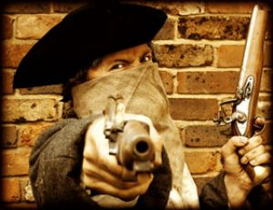
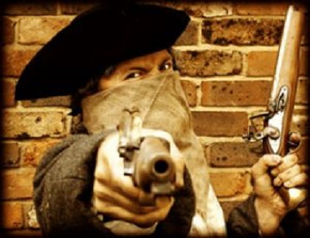
Late one night in 1739 a group of outlaws known as the Kellymount Gang attacked the residence of Captain Donovan of Clonmore, Bree (Griffiths 1877, 300). The Kellymount gang were a notorious band of thieves and robbers, who had their base near Paulstown, in Co. Kilkenny (oldpaulstownstories). From here they raided far and wide, hitting various locations across counties Kilkenny, Wexford, Laois,Offaly and Tipperary. The gang numbered around thirty men and were led by a man named Brennan. He was described as ‘a man of very mean appearance’, who ‘has a freehold of nine pounds per year, near the coal pits, but, renting one of the coal pits, and not succeeding, he started the gang’ (Madden 1867, 277). This band of outlaws gained nationwide notoriety and between 1738 and 1740 they terrorised much of the southeast.
Their attack on Captain Donovan’s house in Clonmore occurred at night and the gang obviously hoped to take him unawares. However, Donovan must have been forewarned as he managed to fortify his home, barricading the doors and windows. He then distributed what arms he possessed amongst his family and servants. The ensuing gunfight was fierce and Captain Donovan himself was shot in the eye. However, eventually the Kellymount Gang conceded defeat after failing to gain access to the house and fled Clonmore.
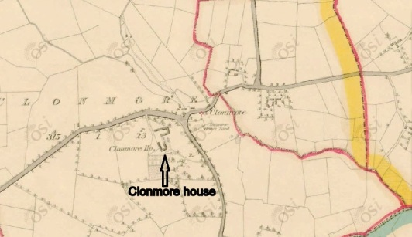Map showing Clonmore House c.1840 (© O.S.I.)
The gang continued on their merry way for some time afterwards but in August 1740 their luck finally ran out. They had been raiding a number of houses and farms in northwest Tipperary when they were surprised by a posse of local gentry (Madden 1867, 274). In attempt to evade their pursuers the gang split in two, but the posse managed to keep Brennan in their sights. The ensuing chase lasted two days and despite a frantic crossing of the River Shannon and a number of shoot-outs the gang’s leader was finally cornered near Portumna in Co. Galway. He was captured after being seriously wounded and was taken to Nenagh jail in Co. Tipperary. He was then transferred to Clonmel prison where in September 1740 he died from his wounds. Darcy, another gang member, was also captured and tried in Carlow. After being found guilty he was hanged and rather gruesomely his head was put on display over the courthouse (ibid, 280). Thus the exploits of the Kellymount Gang came to a bloody end.
References
Griffiths, G. 1877. Chronicles of the County Wexford. Enniscorthy
Madden, R. R. 1867. The History of Irish Periodical Literature from the end of the 17th Century to the middle of the 19th Century. London
URL: http://oldpaulstownstories.wordpress.com/2011/05/29/the-kellymount-gang-circa-1738-1740/ . Accessed 16/2/2012

